LEARNER’S ACADEMY

(An online management system)

GITHUB LINK: https://github.com/AnishAugustin09/LEARNER-S-ACADEMY

**This document contains the:**

* Sprint Planning
* Flow of Project
* Concepts used in Project
* Working on Eclipse IDE
* Conclusion

**Sprint Planning:**

For this project, I’ve planned to complete the project in 5 Sprints. And the task is completed according to that.

**Flow of Project:**

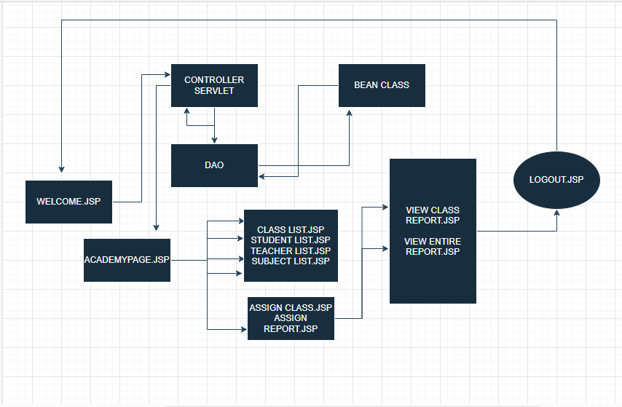

**Concepts used in Project:**

* JSP, HTML & CSS
* JAVA , SERVLET, JSP, JSTL
* MYSQL

Tools & Tech used in Project:

* Eclipse IDE
* Tomcat Server 9.0
* Git & Github

**Working on Eclipse IDE:**

Step 1: Creating a new Dynamic Web Project in Eclipse

● Open Eclipse

● Go to File -> New -> Dynamic Web Project --> Next.

● Type in any project name and click on “Finish.”

● Select your project and go to WEB-INF -> New -> JSP.

● Enter JSP file name and click on “Finish.”

**Step 2:** Writing a program in JSP for the entry point of the application (**WELCOME.JSP).** 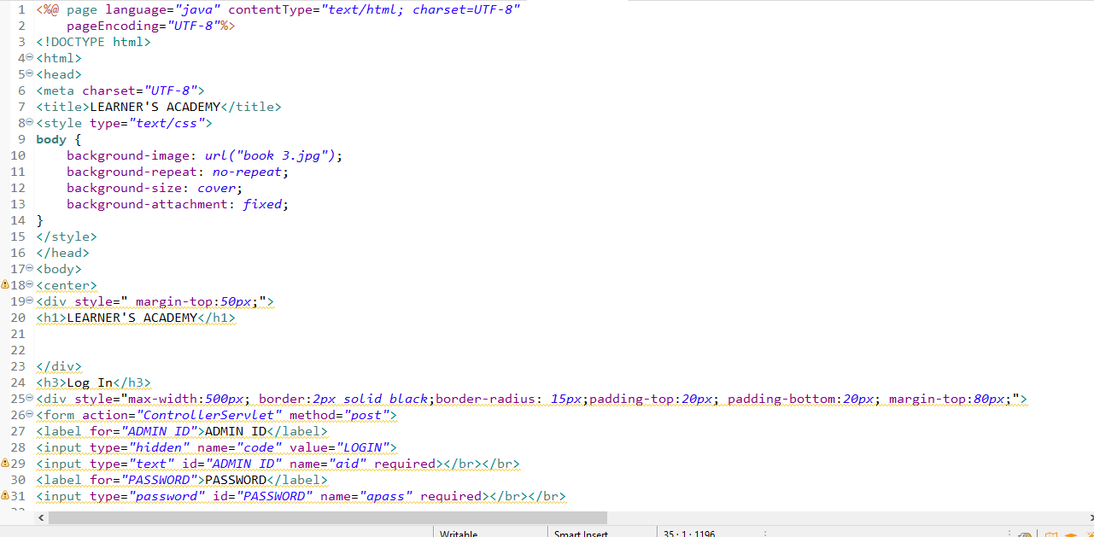

**Step 3:** Create a servlet page which get request and send response (**CONTROLLERSERVLET.Java**).

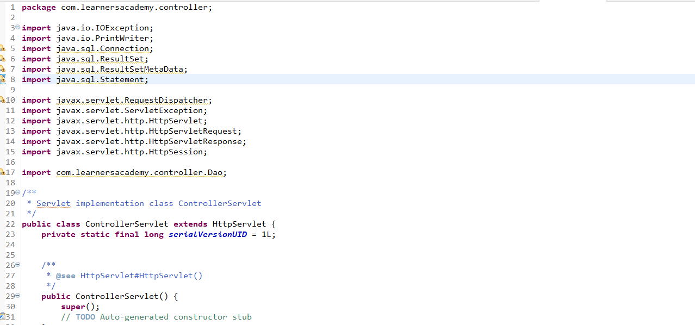

**Step 4:** Create a JAVA class (**DAO.JAVA**) to connect mysql to jdbc.

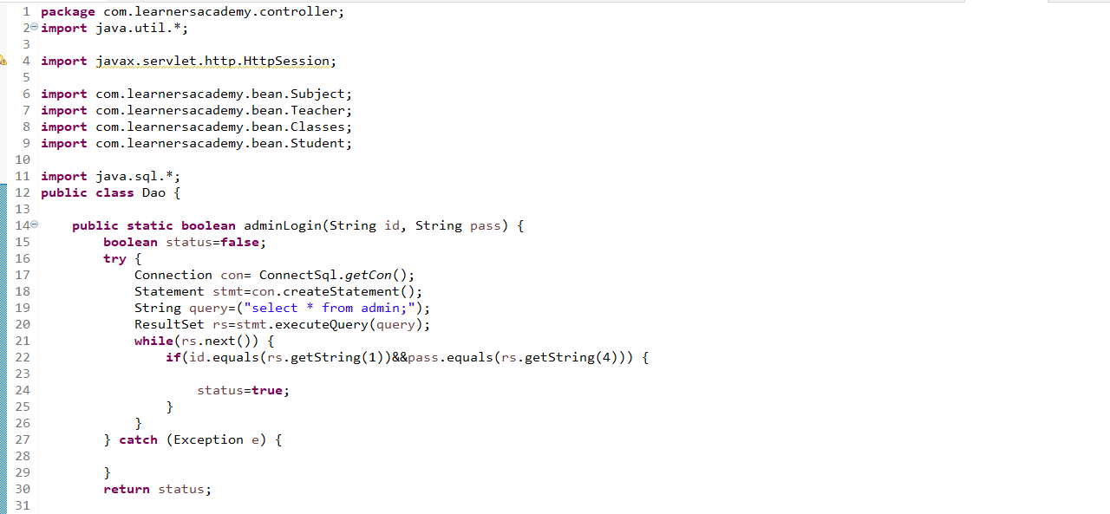

**Step 5:** Create JAVA POJO Class to access the data from Mysql.

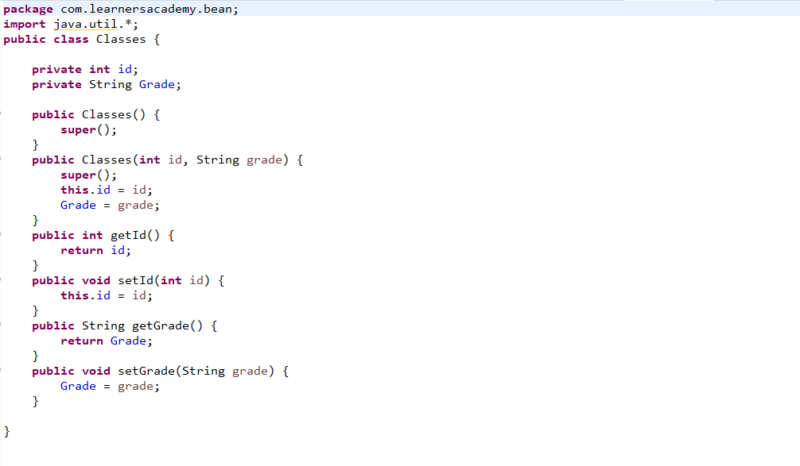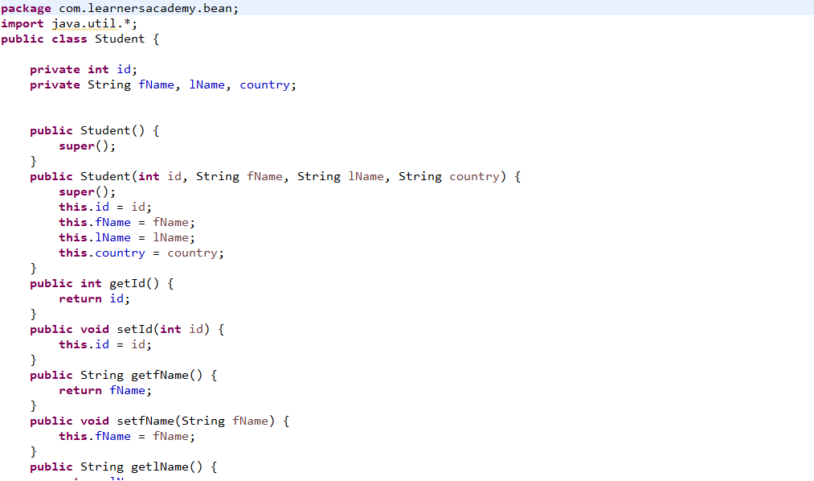

**Step 6:** Using the POJO class, the DAO can access the MYSQL database.

**Step 7:** Create table for the required fields

* Class
* Subject
* Student
* Teacher
* Admin
* Assign Class
* Assign Report

**Step 8:** Add the require JAR files in the **CONFIGURATION PATH & WEB-INF/LIB.**

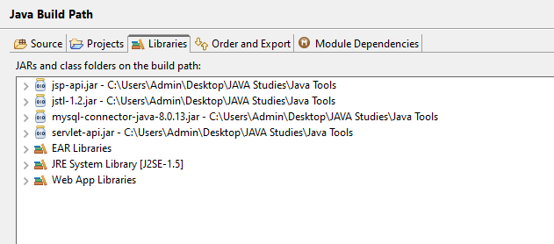

**Step 9:** Using these tables we can access the data’s from the Main Page(**ACADEMYPAGE.JSP**)

**Step 10:** By Creating all the requirements, we can achieve the entire goal of this Project.

This Project met all the requirements:

**1.** **It’s a back-office application with a single administrator login.**

Please use Admin ID: **LA1** & PASSWORD: **121212**

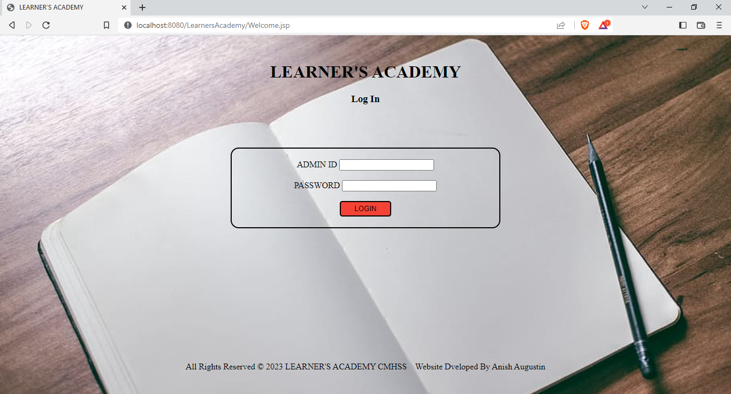

Login Page

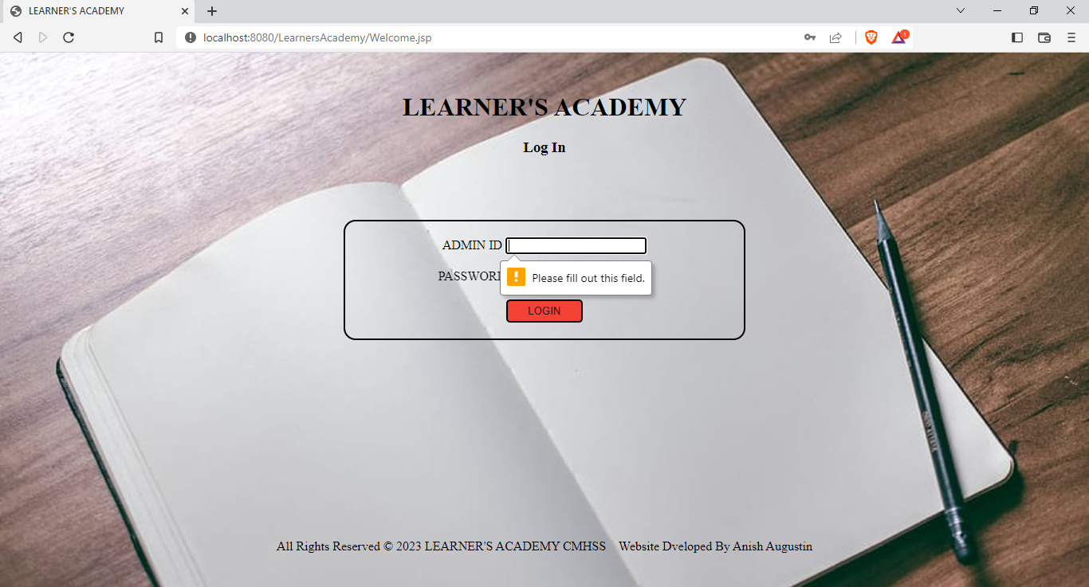Login page will not move to next page without ID & PASS.

**2.The system keeps track of its classes, subjects, students, and teachers..**

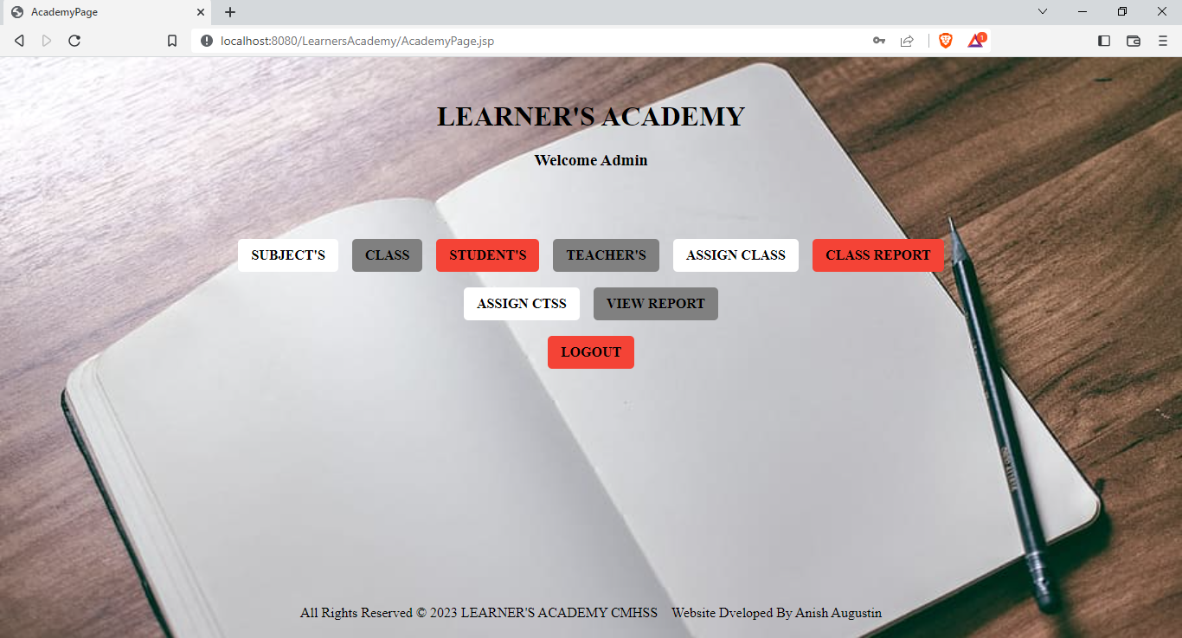

**ACADEMY PAGE**

**3. Set up a master list of all the subjects for all the classes** 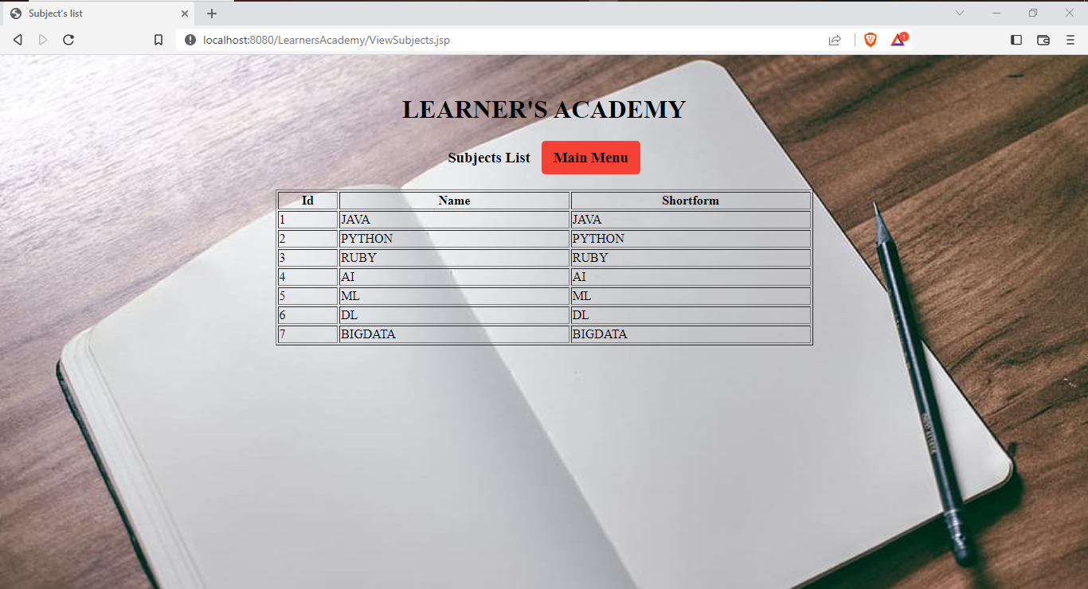

**MASTER SUBJECT LIST**

**4. Set up a master list of all the teachers** 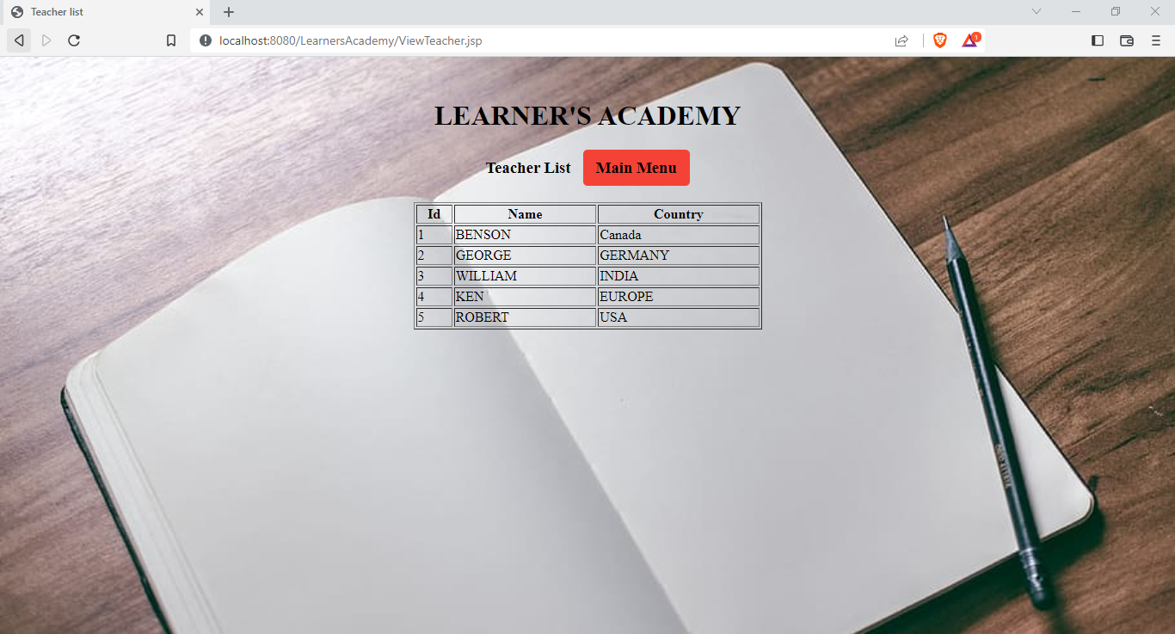

**MASTER TEACHER’S LIST**

**5. Set up a master list of all the classes**

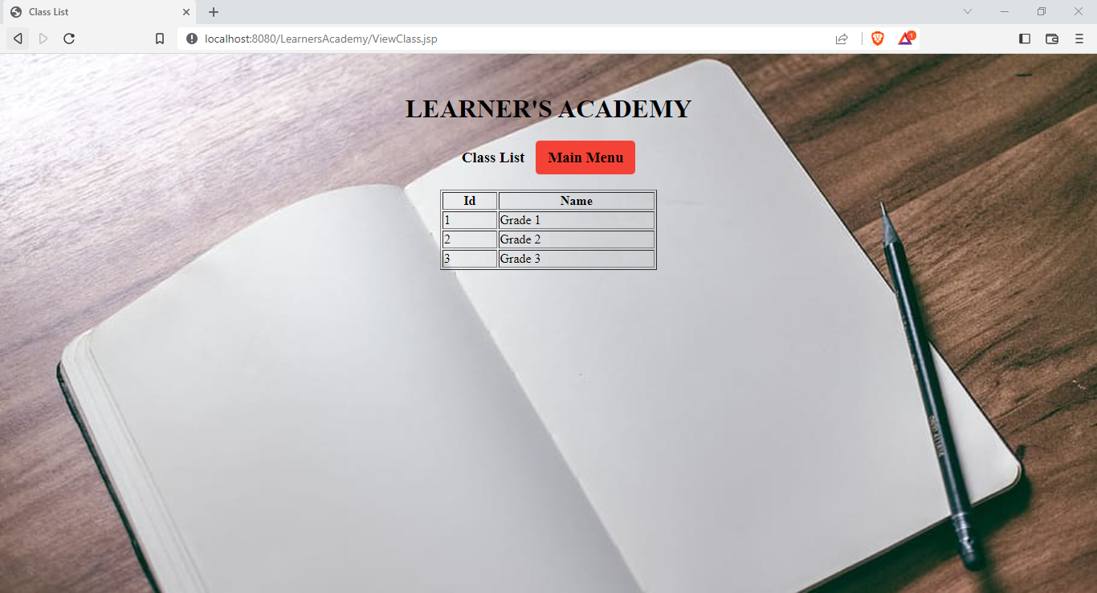

**MASTER** **CLASS LIST**

**6. Assign classes for subjects from the master list**

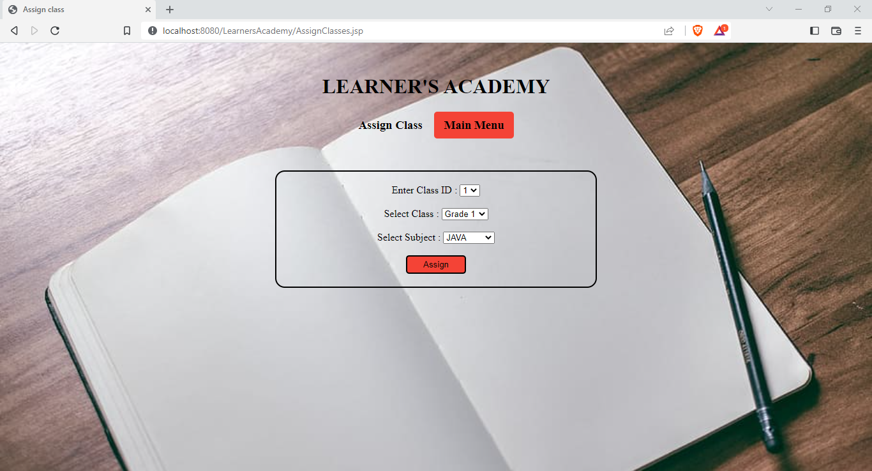

**ASSIGNING CLASS**

**7. Assign teachers to a class for a subject (A teacher can be assigned to different classes for different subjects)**

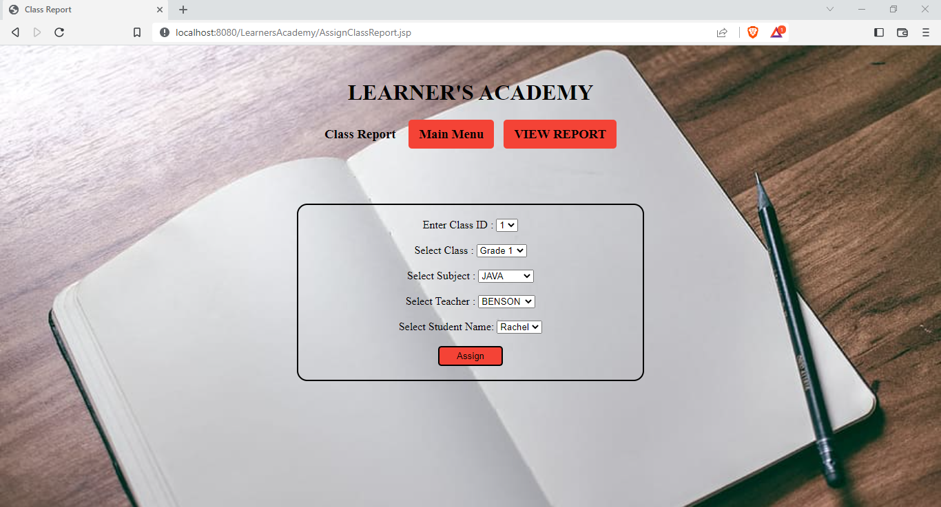

**ASSIGNING REPORT**

**8. Get a master list of students (Each student must be assigned to a single class)**

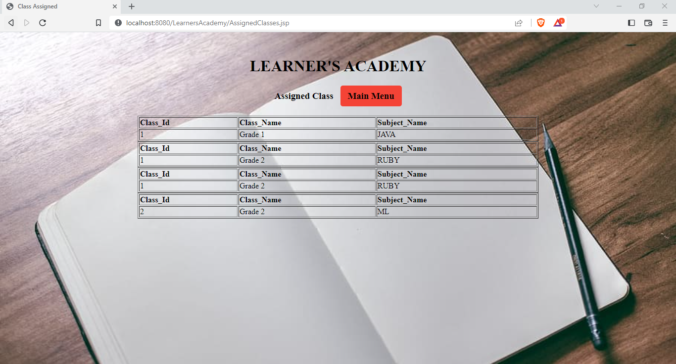

**MASTERLIST CLASSES WITH SUBJECT**

**9. There will be an option to view a Class Report which will show all the information about the class, such as the list of students, subjects, and teachers**

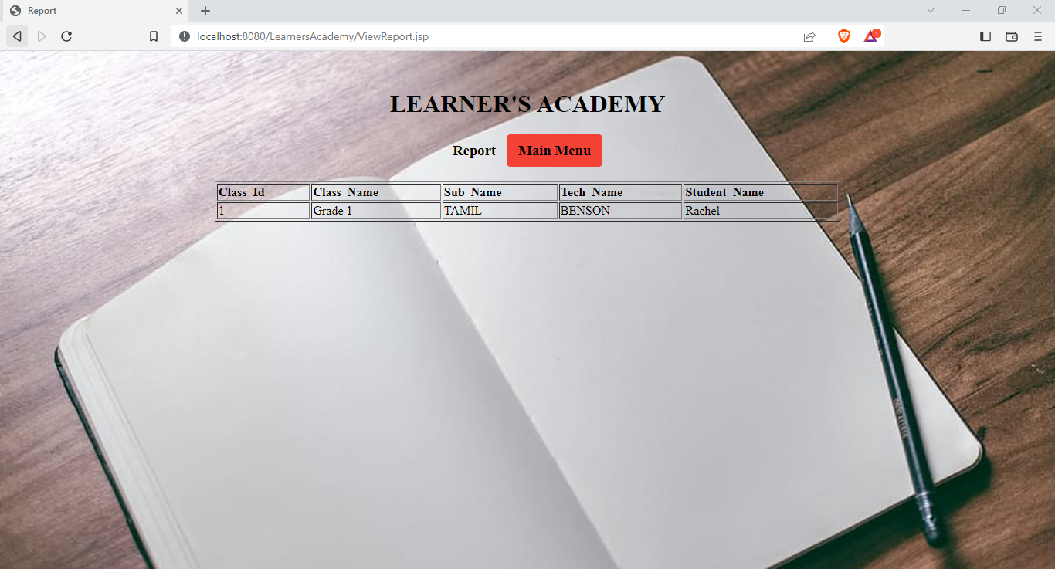

**MASTERLIST OF REPORT**

10. Additional settings (**LOGOUT)**

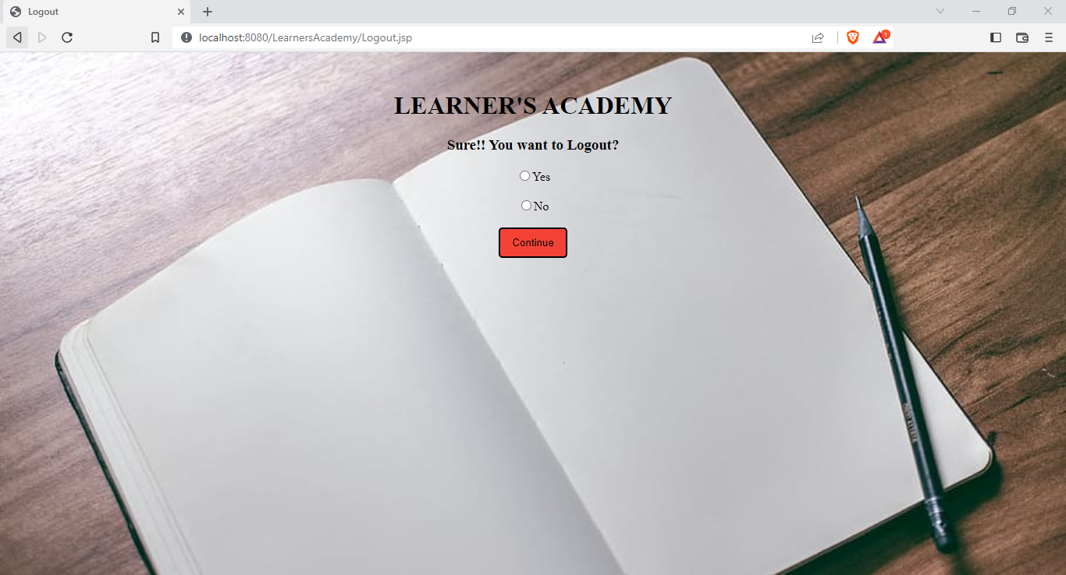

**LOGOUT PAGE**

The goal of the company is to deliver a high-end quality product as early as possible. So, In this Project you can perform

* Admin login
* View Class list
* View Students list
* View Subjects list
* View Teachers list
* Assign Classes with Subjects
* Assign Classes with Subjects, Students & Teachers.

**FINAL SETTING :** Upload files to GitHub Repository

* Open your command prompt and navigate to the folder where you have created your files.
* cd <folder path>
* Initialize repository using the following command:
* git init
* Add all the files to your git repository using the following command:
* git add .
* Commit the changes using the following command:
* git commit . -m <commit message>
* Push the files to the folder you initially created using the following command:
* git push -u origin master

**Unique Selling Points:**

1. This application is use to manage & The system keeps track of its classes, subjects, students, and teachers.
2. This application will keep on running until user close the program.
3. It allows the admin to Assign classes for subjects from the master list, Assign teachers to a class for a subject (A teacher can be assigned to different classes for different subjects)
4. It allows the admin to view class, students, subjects & teachers list.

**Conclusion:**

Further enhancements to the application can be made which may include

Admin should able to add many data’s in the DB

THANK YOU